**Datasets:**

* Dakota’s full database export from 6/6/2025.
* RAM Salesforce contact snapshot 6/11/2025.

Final Merged Dataset:

First name | Last Name | Title | Company Name | Email | Mailing Street | Mailing City | Mailing State | Mailing Zip/Postal Code | Mailing Country | Phone | Company Owner

* Company name merged with account name in Dakota

**Steps Taken**

* Cleaned both datasets to remove duplicates by scanning identical emails
  + Salesforce: 17 duplicates, 48,660 unique emails (out of 48,677, 99.97% quality)
  + Dakota: 12,822 duplicates, 154,203 unique emails (out of 167025, 92.32% quality)
* Wire houses removed from both databases
  + Wire houses included (multiple names of funds by these companies were captured with fuzzy matching (e.g.: if title is Blackrock ___ Fund, then remove)
    - Bank of America / Merril Lynch
    - Wells Fargo
    - Morgan Stanley
    - J.P. Morgan
    - UBS
    - Ameriprise
    - Raymond James
    - Goldman Sachs
    - BlackRock
    - Edward D. Jones
  + Salesforce: 1,177 wire house contacts found, 37,629 non-wire house contacts (77.3%)
  + Dakota: 77,743 wire house contacts found, 76,460 non-wire house contacts (45.78%)
* State ownership for Dakota mapped off Owner ID Excel tab
  + See original here: [RIA_new_contacts_formatted.xlsx](https://rockco-my.sharepoint.com/:x:/r/personal/mbogorad_rockco_com/Documents/MarkB/RIA_new_contacts_formatted.xlsx?d=wd170e790d8b94e8e9b558148c62147c7&csf=1&web=1&e=0oU8uk&nav=MTVfe0Y1Q0VFRDRFLUY2MDctNDkxNy05MUE4LUZEOURFOEE1MUFCM30)

**Key Observations**

* While Salesforce had fewer duplicates, there are a lot of empty fields with corresponding emails. The Dakota merger does not amend this as there is very little overlap between the contacts.
* More international data (London) in Dakota

Data Match: Noteworthy Statistics

* New, non-overlapping contacts added from Dakota: 76,122
* Total contacts after data merger: 113,750
* Dakota contacts that overlapped with Salesforce (were excluded in final data): 0.44%

**Appendix:**

Dakota Pre Wire House Removal

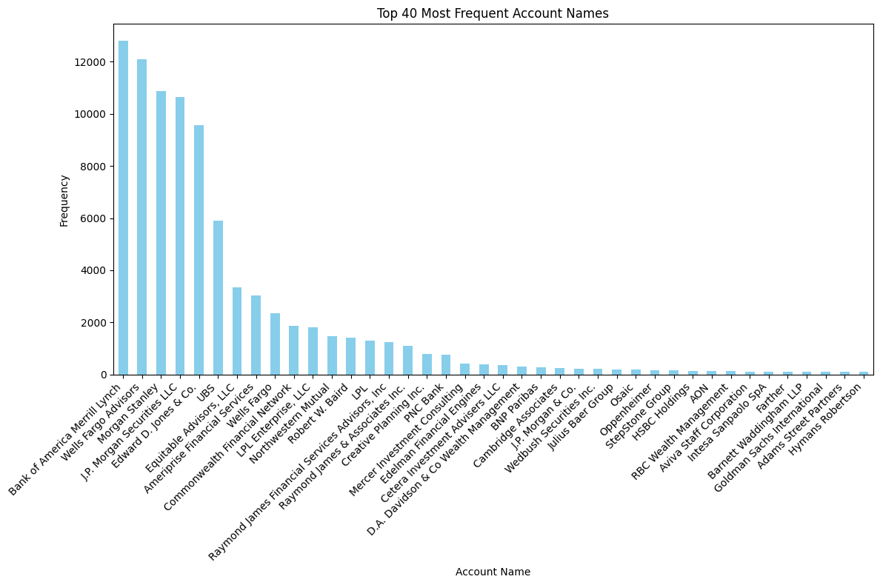

Dakota Post Wire House Removal

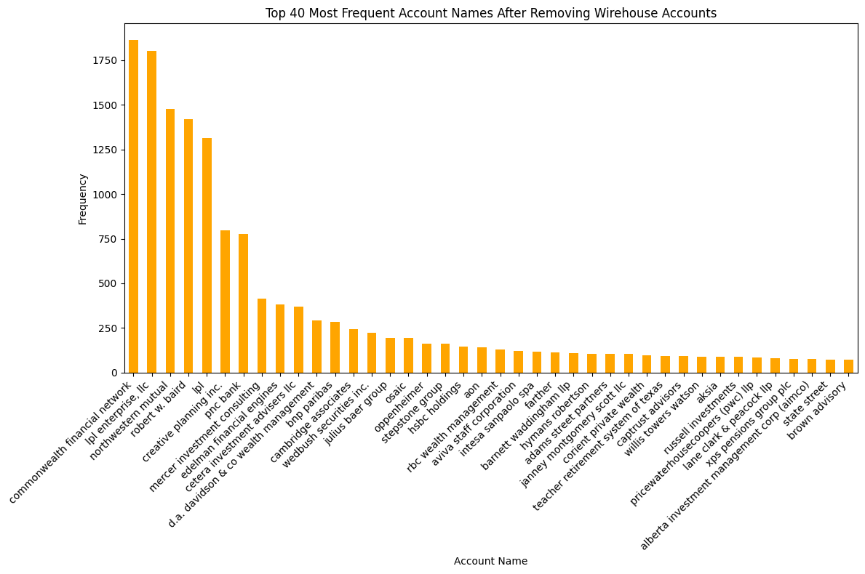

Salesforce Most Common Company Name

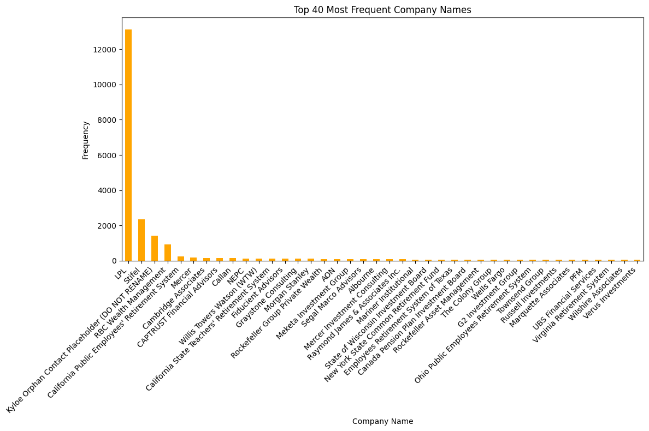

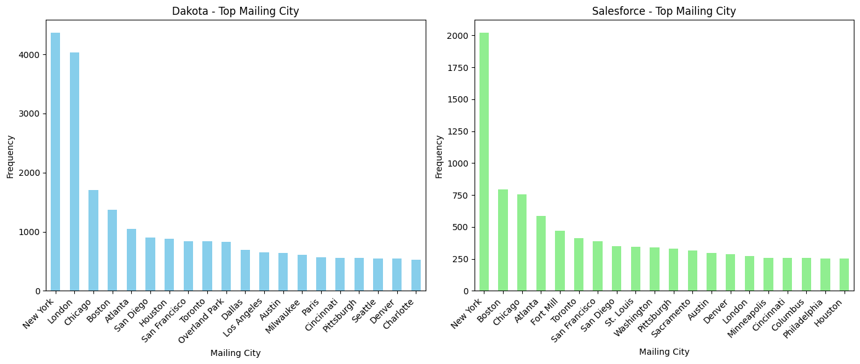

Wirehouses Found in Salesforce Wirehouses Found in Dakota

|  |  |
| --- | --- |
| Wells Fargo | 19492 |
| Merrill Lynch | 12809 |
| Morgan Stanley | 10973 |
| J.P. Morgan | 10911 |
| Edward Jones | 9568 |
| UBS | 6593 |
| Ameriprise | 3954 |
| Raymond James | 2933 |
| Goldman Sachs | 272 |
| BlackRock | 237 |
| Total | 77742 |

|  |  |
| --- | --- |
| Wells Fargo | 398 |
| Ameriprise | 189 |
| Raymond James | 136 |
| UBS | 124 |
| Morgan Stanley | 117 |
| Merrill Lynch | 66 |
| Goldman Sachs | 48 |
| J.P. Morgan | 45 |
| BlackRock | 42 |
| Edward Jones | 12 |
| Total | 1177 |

Missing Values in Salesforce (cleaned) Missing Values in Dakota (cleaned)

|  |  |
| --- | --- |
| Salutation | 37625 |
| First Name | 106 |
| Last Name | 0 |
| Title | 2275 |
| Company Name | 0 |
| Mailing Street | 10619 |
| Mailing City | 1427 |
| Mailing State/Province | 2279 |
| Mailing Zip/Postal Code | 22078 |
| Mailing Country | 1286 |
| Phone | 6431 |
| Fax | 27533 |
| Mobile | 37623 |
| Email | 0 |
| Company Owner | 0 |

|  |  |
| --- | --- |
| ContactID | 0 |
| First Name | 30 |
| Last Name | 0 |
| Email | 0 |
| Account ID | 0 |
| Account Name | 0 |
| Metro Area: | 22 |
| Phone | 821 |
| Title | 4 |
| Contact Type | 8 |
| Asset Class Coverage | 23 |
| Mailing Street | 523 |
| Mailing City | 20 |
| Mailing State/Province | 13949 |
| Mailing Zip/Postal Code | 631 |